FORM G
G
SCHOOL:

STUDENT NUMBERS ATTENDING:
- Staff to student’s ratio is 1:20. (Dependant on participating student needs)
- Please send to RBSLEC, whenever numbers change.

BOYS: |  | GIRLS: |  | TOTAL:

** Please list any students attending that have not given media consent clearance to the school** RBSLEC may use images of camp without student names.

Please clarify if visiting staff are the following: TA (Teacher Aide), ST (Student Teacher), PA (Parent assistant), PST (Pre Service Teacher) SEU (Special Ed Teacher). Please indicate if unavailable for standard duties.
STAFF NUMBERS ATTENDING: (Please print – full name and gender)

1 |  | 6
2 |  | 7
3 |  | 8
4 |  | 9
5 |  | 10

ARRIVALS & DEPARTURES: (please indicate)
The standard time for arrival at camp is 10am, we will arrive at ___________ .
The standard departure time from camp is 1pm, we will depart at _________ .
Yes we intend to leave early and will require a packed lunch. We understand that we are responsible for providing our own cool storage ie. esky

We will be arriving/departing camp by bus
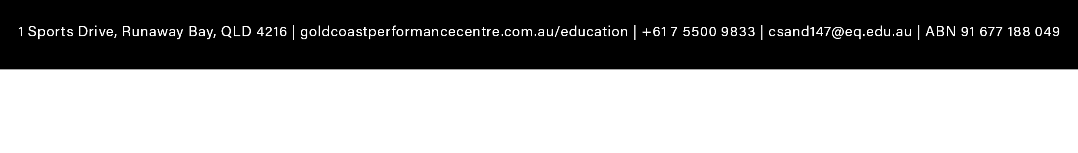
sWe will be arriving by private pick-up/drop/off

