Sport Development Day Coordinator Form
School: |  |  |  | Name:
Date of camp: |  |  |  | Phone:
Year Level: |  |  |  | Mobile:
No. of Students: |  |  |  | Email:
Arrival Time: |  |  |  | Depart Time:
Transport (Bus/Private):

CAMP FOCUS: Please select the key camp focus for your group (Choose multiple if applicable):
Team building/develop cohesion Intense training camp Experience an elite environment
Challenge students to get out of their comfort zone Competition preparation
Complement the specific team/school program (Please email details) Other (Please email details)
DAY ACTIVITIES: Please select from the following preferences (3-5 sessions per full day)
MIND and BODY PREPARATION  Before and after performance |  | FITNESS  Conditioning yourself for performance |  | COMPETITION  Yourself against others |  | LEADERSHIP/TEAM CULTURE  Yourself with others
Yoga |  | Speed/Agility session |  | - Triathlon (Double Session)  - Duathlon  - Aquathlon |  | Military Boot Camp
Roller Flexibility |  | Spin Class |  | Archery |  | Team Obstacle Course
Pilates |  | Boxercise |  | Indigenous Kombumerri Games |  | Stand Up Paddle boarding (Double session)
Ice Baths & Pool Recovery |  | High Intensity Interval Training (HIIT) Session |  | Cross-Training games |  | Kayaking (Double session)
Workshop:  - Long-Term Athlete Development  - Elite Athlete Training  - Mobility and Functional Movement  - Sports Injury Prevention  - Strength & Conditioning  - Team Culture |  | Fitness Circuit |  | Beach Volleyball |  | Initiative games
 |  | Fitness testing - components of fitness |  |  |  | Outdoor Team Challenges
 |  | Intro to strength and conditioning (Gym/ Barbell Training) |  |  |  | Mini-Olympics – multi-sport  (Double session)
 |  | Beach Fitness (With SUPing) |  |  |  | Prouty’s Landing
 |  | Track running/sprints
 |  | Swimming
 |  | Cycling
Note: Single session times are generally between 45-75 minutes depending on the activity.

RBSLEC Activity Descriptions
Amazing Race  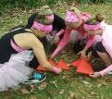 | This activity combines physical challenges, mental puzzles, and critical thinking problems. Amazing Race is the ultimate test for teamwork and the perfect platform for leadership growth. Students will move around the centre in small groups returning to ‘base’ to complete challenges.
Aquatic games/Pool Swim  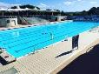 | This activity builds confidence in the water as students participate in team-oriented games aimed at supporting one another, challenging fitness and having fun in a non-weighted environment. Takes place either in the 20m indoor pool (shallow) or the 50m outdoor pool (min 2m depth)
Archery  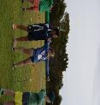 | Through experiential learning students learn how to successfully fire an arrow at a stationary target. This activity challenges students’ focus and self-control.
Beach Games  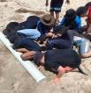 | This involves a series of games designed to promote effective communication and build leadership qualities. These team-oriented games allow all to grow in confidence while having fun in the picturesque environment of the Gold Coast Broadwater. Students will be digging in the sand and required to wade in ankle-deep water.
Beach volleyball  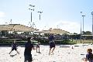 | Students will be instructed in the fundamentals of this sport. Some skills and mini games will be incorporated. Takes place on the Olympic standard court. Students will be barefoot for this activity.
Cycling | Students will learn the skills necessary to ride on the road as a cyclist, building confidence in safety manoeuvres, indicating, giving way to others and stopping. Cyclists will then be given the opportunity to compete in team challenges around the Luke Harrop Memorial Track.
Field games | Hybrid games take place either on the hockey pitch or main field. These encourage quick critical thinking and develop skills such as speed, balance and coordination. (Sports-inspired games)
Fitness Testing  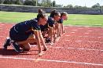 | In this activity, students will be encouraged to push themselves to their limits and test their abilities with our state-of-the-art facilities and fitness-testing equipment. They will use our world-class timing gates to test speed, acceleration and agility. Students will also have the opportunity to use the Olympic-standard running track to test aerobic capacity, muscular endurance and cardiovascular fitness.
Fitness Activities  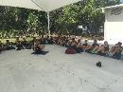  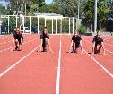 | Spin Class- Get the music pumping and challenge your students’ mental toughness with this high intensity cycling session, in a fun team environment.  Fitness circuit- Medium to high intensity training focussing on a range of fitness components, incorporating new and innovative exercises to create a fun and interesting session.  HIIT – High Intensity Interval Training, combining the use of gym and matrix equipment, body weight exercises and kinaesthetic training.  Sand/beach fitness- Body weight exercise session at the beach for a more challenging workout.  Functional Flexibility- Learn how to prepare for exercise with dynamic movement, and cool-down with foam rolling and static stretching techniques.  Boxercise- Get the gloves on and combine continuous cardio-vascular training with the high intensity of boxing.  Strength and Conditioning- Step into the shoes of the elite, and train in our world class gymnasium and Commonwealth Games venue.  Triathlon/Duathlon- Dive into our 50m Olympic pool, run on the IAAF Track and cycle around the Luke Harrop Memorial track to complete this ultimate test of physical and mental toughness.  Speed for Sport- All student athletes can benefit from improved acceleration, agility and speed. Develop these skills on our IAAF track with specific training techniques and activities.
Mini Olympics  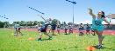 | Take team building to the next level, develop the grit, determination and resilience to compete in these sporting competitions, whether it is soccer, volleyball, basketball or athletic events. There is something here for every age and skill level.
Ice Bath & Pool Recovery  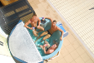 | During their camp, students have the opportunity to walk in the footsteps of elite athletes. This includes training and recovering like some of their sporting heroes. They will learn the benefits of using an ice bath for recovery.
Indigenous Kombumerri  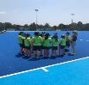  Games | Fun, competitive Traditional Indigenous games that provide students an opportunity to learn about, appreciate and experience aspects of Aboriginal and Torres Strait Islander cultures. Suitable for all ages, abilities and backgrounds.
Initiative Games  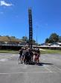 | Extreme problem-solving and physical activity give the perfect stage to step up and show initiative. Who will take charge, accept the input of others and listen in order to achieve success?
Kayak Adventure  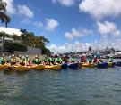 | Challenge your students’ teamwork and mental toughness as they embark on this exciting but challenging adventure around the local islands of the Gold Coast Broadwater. Sessions will be tailored to the age level and ability of the group. Wet shoes are required.
Laser Tag  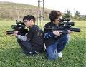 | Actioning support, communication, and cooperation is the only way to succeed. With Military Precision teams move to attack the enemy and record their accuracy rate. They will set up a perimeter to defend the VIP and battle to gain victory.
Military  Boot Camp  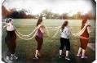 | Step-up and accept the challenge of this military style team fitness activity. Students will need to be disciplined in their approach to challenges and show mental strength to push through setbacks and gain victory. Only the teams who demonstrate effective communication, support and cooperation will be successful.
Night Activities | Trivia- A mixed bag of Q&A in a team environment.  Movie Night- School chooses a suitable film for their group. Large double screen projectors in conference room.  DJ/Disco Night- Get your dancing shoes on and have some evening fun as our DJ plays a range of student-appropriate music and gets everyone involved in some games and activities.  Guess those Lyrics- Modelled off the TV game show, students work in small teams to guess the next lyrics of the song on the screen. Singing and dancing are worked into the points system.  Astronomy/ Science- Be entertained with the joys of science and discover the solar system through the use of telescopes.
Outdoor Team Challenge  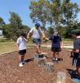 | Test your communication and team-building skills on various outdoor challenges. This is a great activity to see a diverse range of students come together to achieve success. Challenges are adapted for a variety of age levels.
Photo Scavenger Hunt  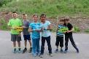 | Teams move around the Centre in small groups in order to collect clues and eventually code crack open a treasure chest. Students are trusted to organise and motivate themselves independently from their teachers.
Pilates  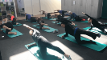 | Pilates emphasizes proper postural alignment, core strength and muscle balance. Students will be put through a session of low-impact flexibility and muscular strength and endurance movements.
Raft Building  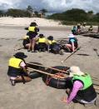 | Students are provided with certain buoyant materials and are challenged to construct a raft to paddle on the Broadwater. This activity targets creativity and team organization.
Slingshot challenge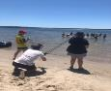 | A three-person operated slingshot is used to launch objects for the team to collect for points. Can take place either on the hockey field or at the Broadwater location. This activity can require students to be in waist-depth water.
Team Obstacle Course  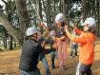 | An opportunity for team collaboration as students make their way through various obstacles, including a low ropes challenges.
Stand Up Paddle Boarding  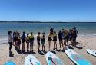 | Participate in this fun and challenging introductory course delivered at Shearwater Park on the beautiful Gold Coast Broadwater. Students will learn the basic maneuvers associated with SUPing and will work together to challenge themselves with some fun activities.
Yoga  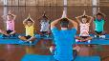 | A mix of stretching and breathing to assist with focus and agility.
Prouty’s Landing/Team balance board  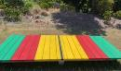  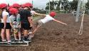 | Prouty’s Landing is an extension activity of the low ropes course and involves the team swinging from one platform to another without falling off.  Team balance board is a whole-team activity which requires the group to self manage while trying to balance on a giant see saw.

