Sport Development Camp Coordinator Form
School: |  |  |  | Name:
Date of camp: |  |  |  | Phone:
Year Level: |  |  |  | Mobile:
No. of Students: |  |  |  | Email:
Arrival Time: |  |  |  | Depart Time:
Transport (Bus/Private):

CAMP FOCUS: Please select the key camp focus for your group (Choose multiple if applicable):
Team building/develop cohesion Intense training camp Experience an elite environment
Challenge students to get out of their comfort zone Competition preparation
Complement the specific team/school program (Please email details) Other (Please email details)
DAY ACTIVITIES: Please select from the following preferences (3-5 sessions per full day)
MIND and BODY PREPARATION  Before and after performance |  | FITNESS  Conditioning yourself for performance |  | COMPETITION  Yourself against others |  | LEADERSHIP/TEAM CULTURE  Yourself with others
Yoga |  | Speed/Agility session |  | Triathlon/Duathlon (Double Session) |  | Military Boot Camp
Roller Flexibility |  | Spin Class |  | Video analysis feedback (small sided games) |  | Team Obstacle Course
Pilates |  | Boxercise |  | Indigenous Games |  | Stand Up Paddleboarding (Double session)
Ice Baths & Pool Recovery |  | High Intensity Interval Training (HIIT) Session |  | Cross-Training games |  | Kayaking (Double session)
Workshop: Athlete Development/Training Habits/Sports Psychology |  | Fitness Circuit |  | Beach Volleyball |  | Initiative games
Workshop: Feedback - How to give and receive it |  | Fitness testing - components of fitness |  | Archery |  | Outdoor Team Challenges
 |  | Intro to strength and conditioning |  |  |  | Laser Tag
 |  | Beach Fitness (With SUPing) |  |  |  | Mini-Olympics – multi-sport  (Double session)
 |  | Track running/sprints |  |  |  | Workshop: Team Values & Leadership
 |  | Swimming |  |  |  | Prouty’s Landing
Note: Single session times are generally between 45-75 minutes depending on the activity.
NIGHT ACTIVITIES: Please select from the following preferences (1-2 sessions per night)
Outdoor Field Games Movie Night Indoor Pool Games DJ/Disco Night
Guess Those Lyrics Sports Trivia
Example day of a camp program
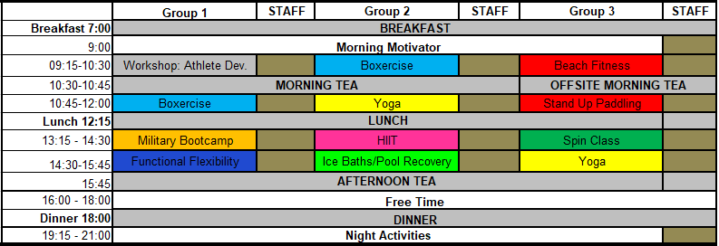
RBSLEC Sports Excellence programs are aligned with the Personal and Social Capabilities of the national curriculum.

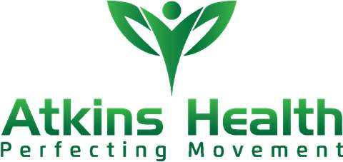
INTERACTIVE WORKSHOPS
The Runaway Bay Sport and Leadership Excellence Centre partners with the team at Atkins Health who are recognised experts in preparing and managing elite athletes through effective training and recovery programs.
Look below to include an interactive workshop in your Sport Development camp to provide your students with the unique opportunity to learn from the leaders in these
high-performance fields.

Activity | Description
LONG-TERM ATHLETE DEVELOPMENT | This lecture and practical session will teach you how to build a strong foundation as an athlete, not just in a specific sport. You will learn fundamentals of key movements, key training variables and tips on monitoring fatigue, overtraining and more to maximise performance.
ELITE ATHLETE TRAINING | This class will train you like an athlete, focusing on strength, power, agility, muscular endurance, and flexibility.
MOBILITY AND FUNCTIONAL MOVEMENT | A practical workshop where you will learn techniques for soft tissue muscle release and why mobility is critical to efficient and optimal performance.
STRENGTH & CONDITIONING SEMINAR | Strength and Conditioning are integral elements to an athlete’s career and performance.  This interactive workshop will explore the fundamental strength and conditioning protocols that are necessary to achieve optimal performance.  Tailored to the needs of your chosen sport, our team of Exercise Physiologists will put you through your paces and help you not only understand but feel the difference when training effectively.
SPORTS INJURY PREVENTION | An invaluable lecture for any young athlete, this session covers the importance of warmups, cool downs, stretching, protective equipment and how to identify any predisposition to injury or illness. You will also learn about rehabilitation techniques and how to safely return to activity after initial treatment. Learn how to come back from injury, and more. For individuals and teams. (Min 20, Max 30 people).
Please Note: 1 workshop free of charge. Additional workshops (or including in day programs) will be an extra charge.

